Engineering College Ajmer
Department of Electrical Engineering
B. TECH, VIII Sem (2024-25)
Revised Class Time Table
Ref: - ECA/EE/2025/292 W.E.F.: - 03/03/2025
DAY  TIME | 9:00 AM  to  9:50 AM | 9:50 AM  to  10:40 AM | 10:40 AM  to  11:30 | 11:30 AM  to  12:20 PM | 12:20 AM  to  1:10 PM | 1:10 AM  to  2:00 PM | 2:00 AM  to  2:50 PM
MON |  | EIAA  (SA)  S-17 | Major Project, (EE – 2)  (AA & MS)  EE – 13
TUE |  |  | Seminar (EE – 1)  (JKD & AA & DKM)  CE – 14
WED |  | EIAA  (SS)  S-17 | Major Project, (EE – 2)  (AA & MS)  EE – 13
THU |  | EIAA  (SS)  S-17 | Seminar (EE – 2)  (JKD & AA & DKM)  CE – 14
FRI |  | U  N | Co-Curricular Activities, (EE – 2)  EE – 13
SAT |  | C  H | Co-Curricular Activities, (EE – 1)  EE – 13
JKD = Dr. Jitendra Kr. Deegwal, AA = Mr. Ajay Agarwal, SS = Dr. Suresh Sahu, SA = Dr. Sikha Agarwal,
DKM = Mr. Dinesh Kumar Meena, MS = Ms. Mahima Sharma,

Copy to: - 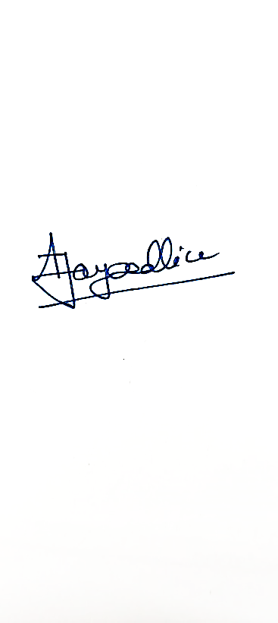
- Principal for kind information (Mr. Ajay Agarwal) (Dr Ajay Dadhich)
- Main Co-ordinator Academics Time Table Co – Ordinator HOD (EE)
- Notice Board
- Concern Faculty members

